

A1

A2

B1

**Figure 1.** Single cell response to a synaptic input. **A:** LFP is shown in blue calculated from the corresponding electrode, shown as a black dot. The synapse is shown in red for the pyramidal (1) and interneuron (2).

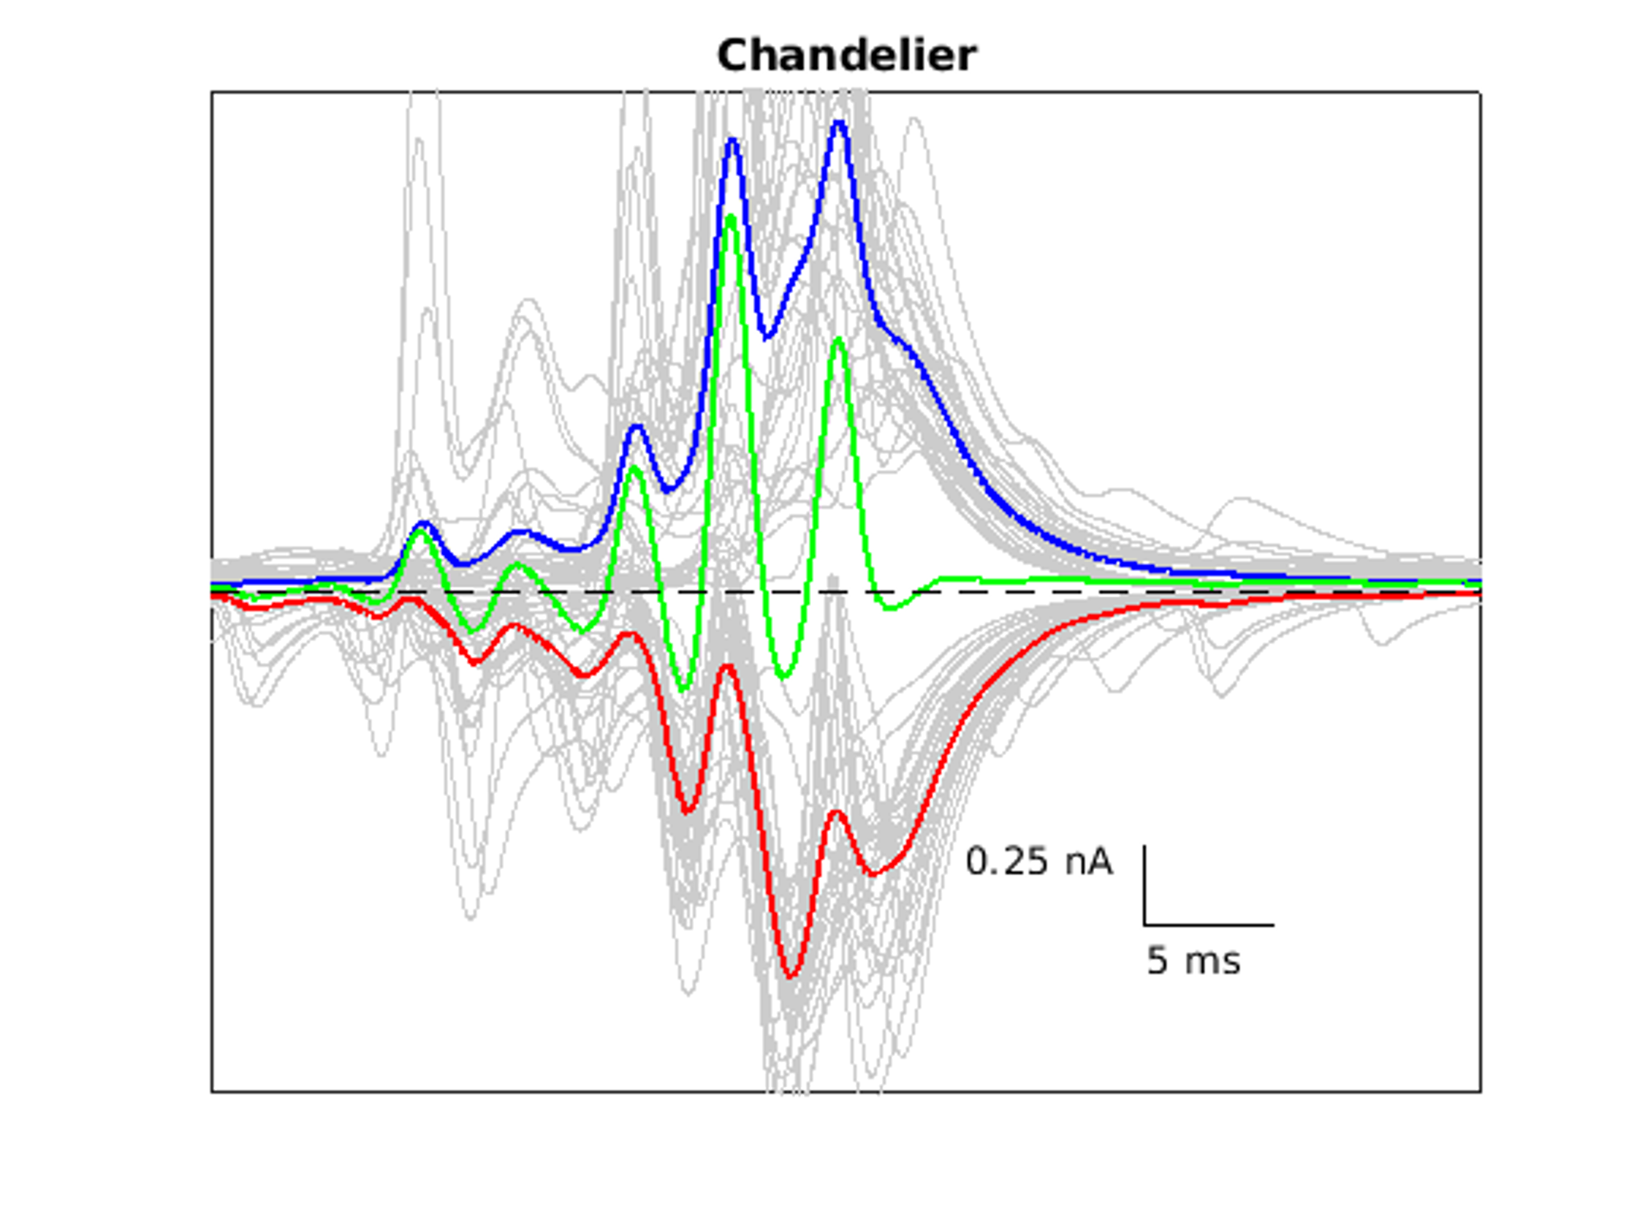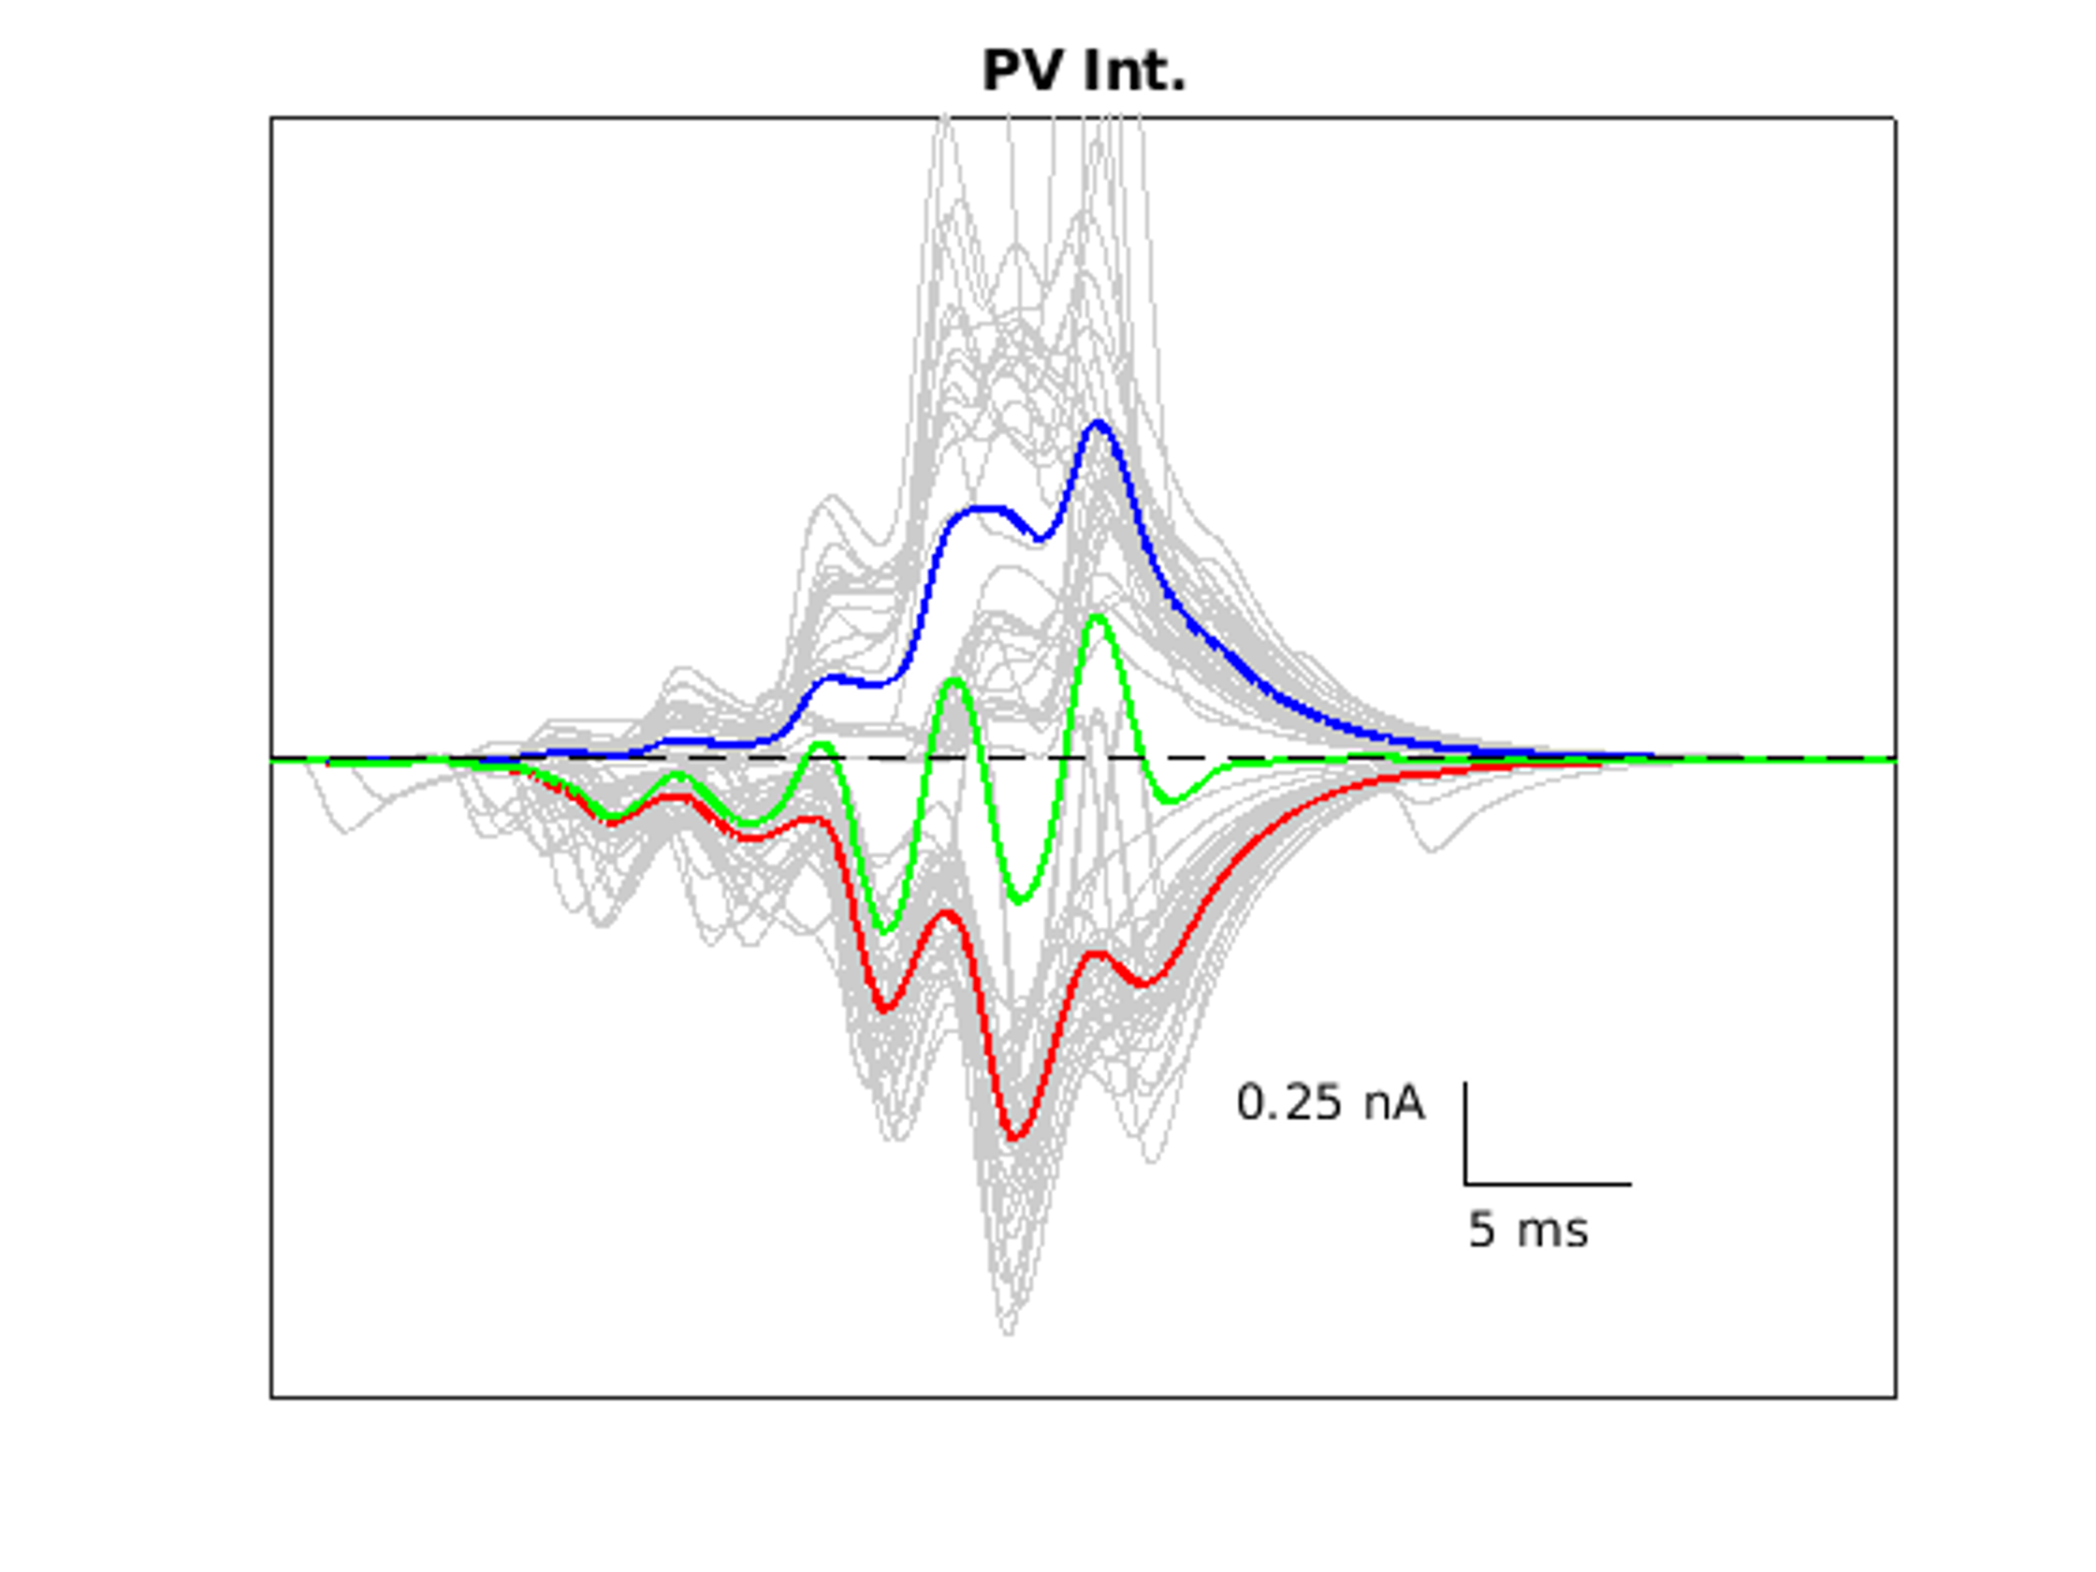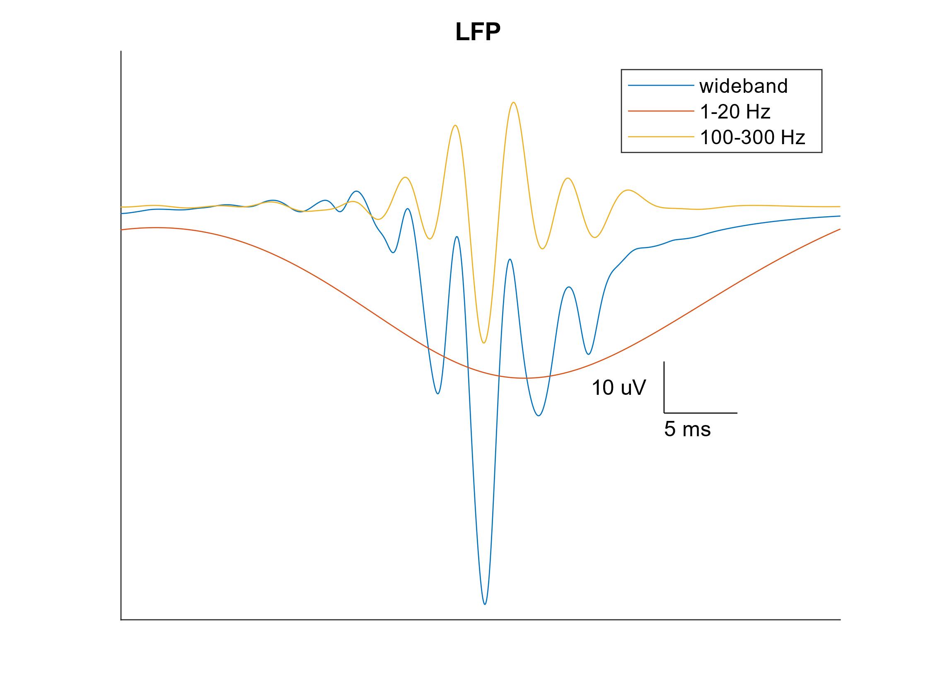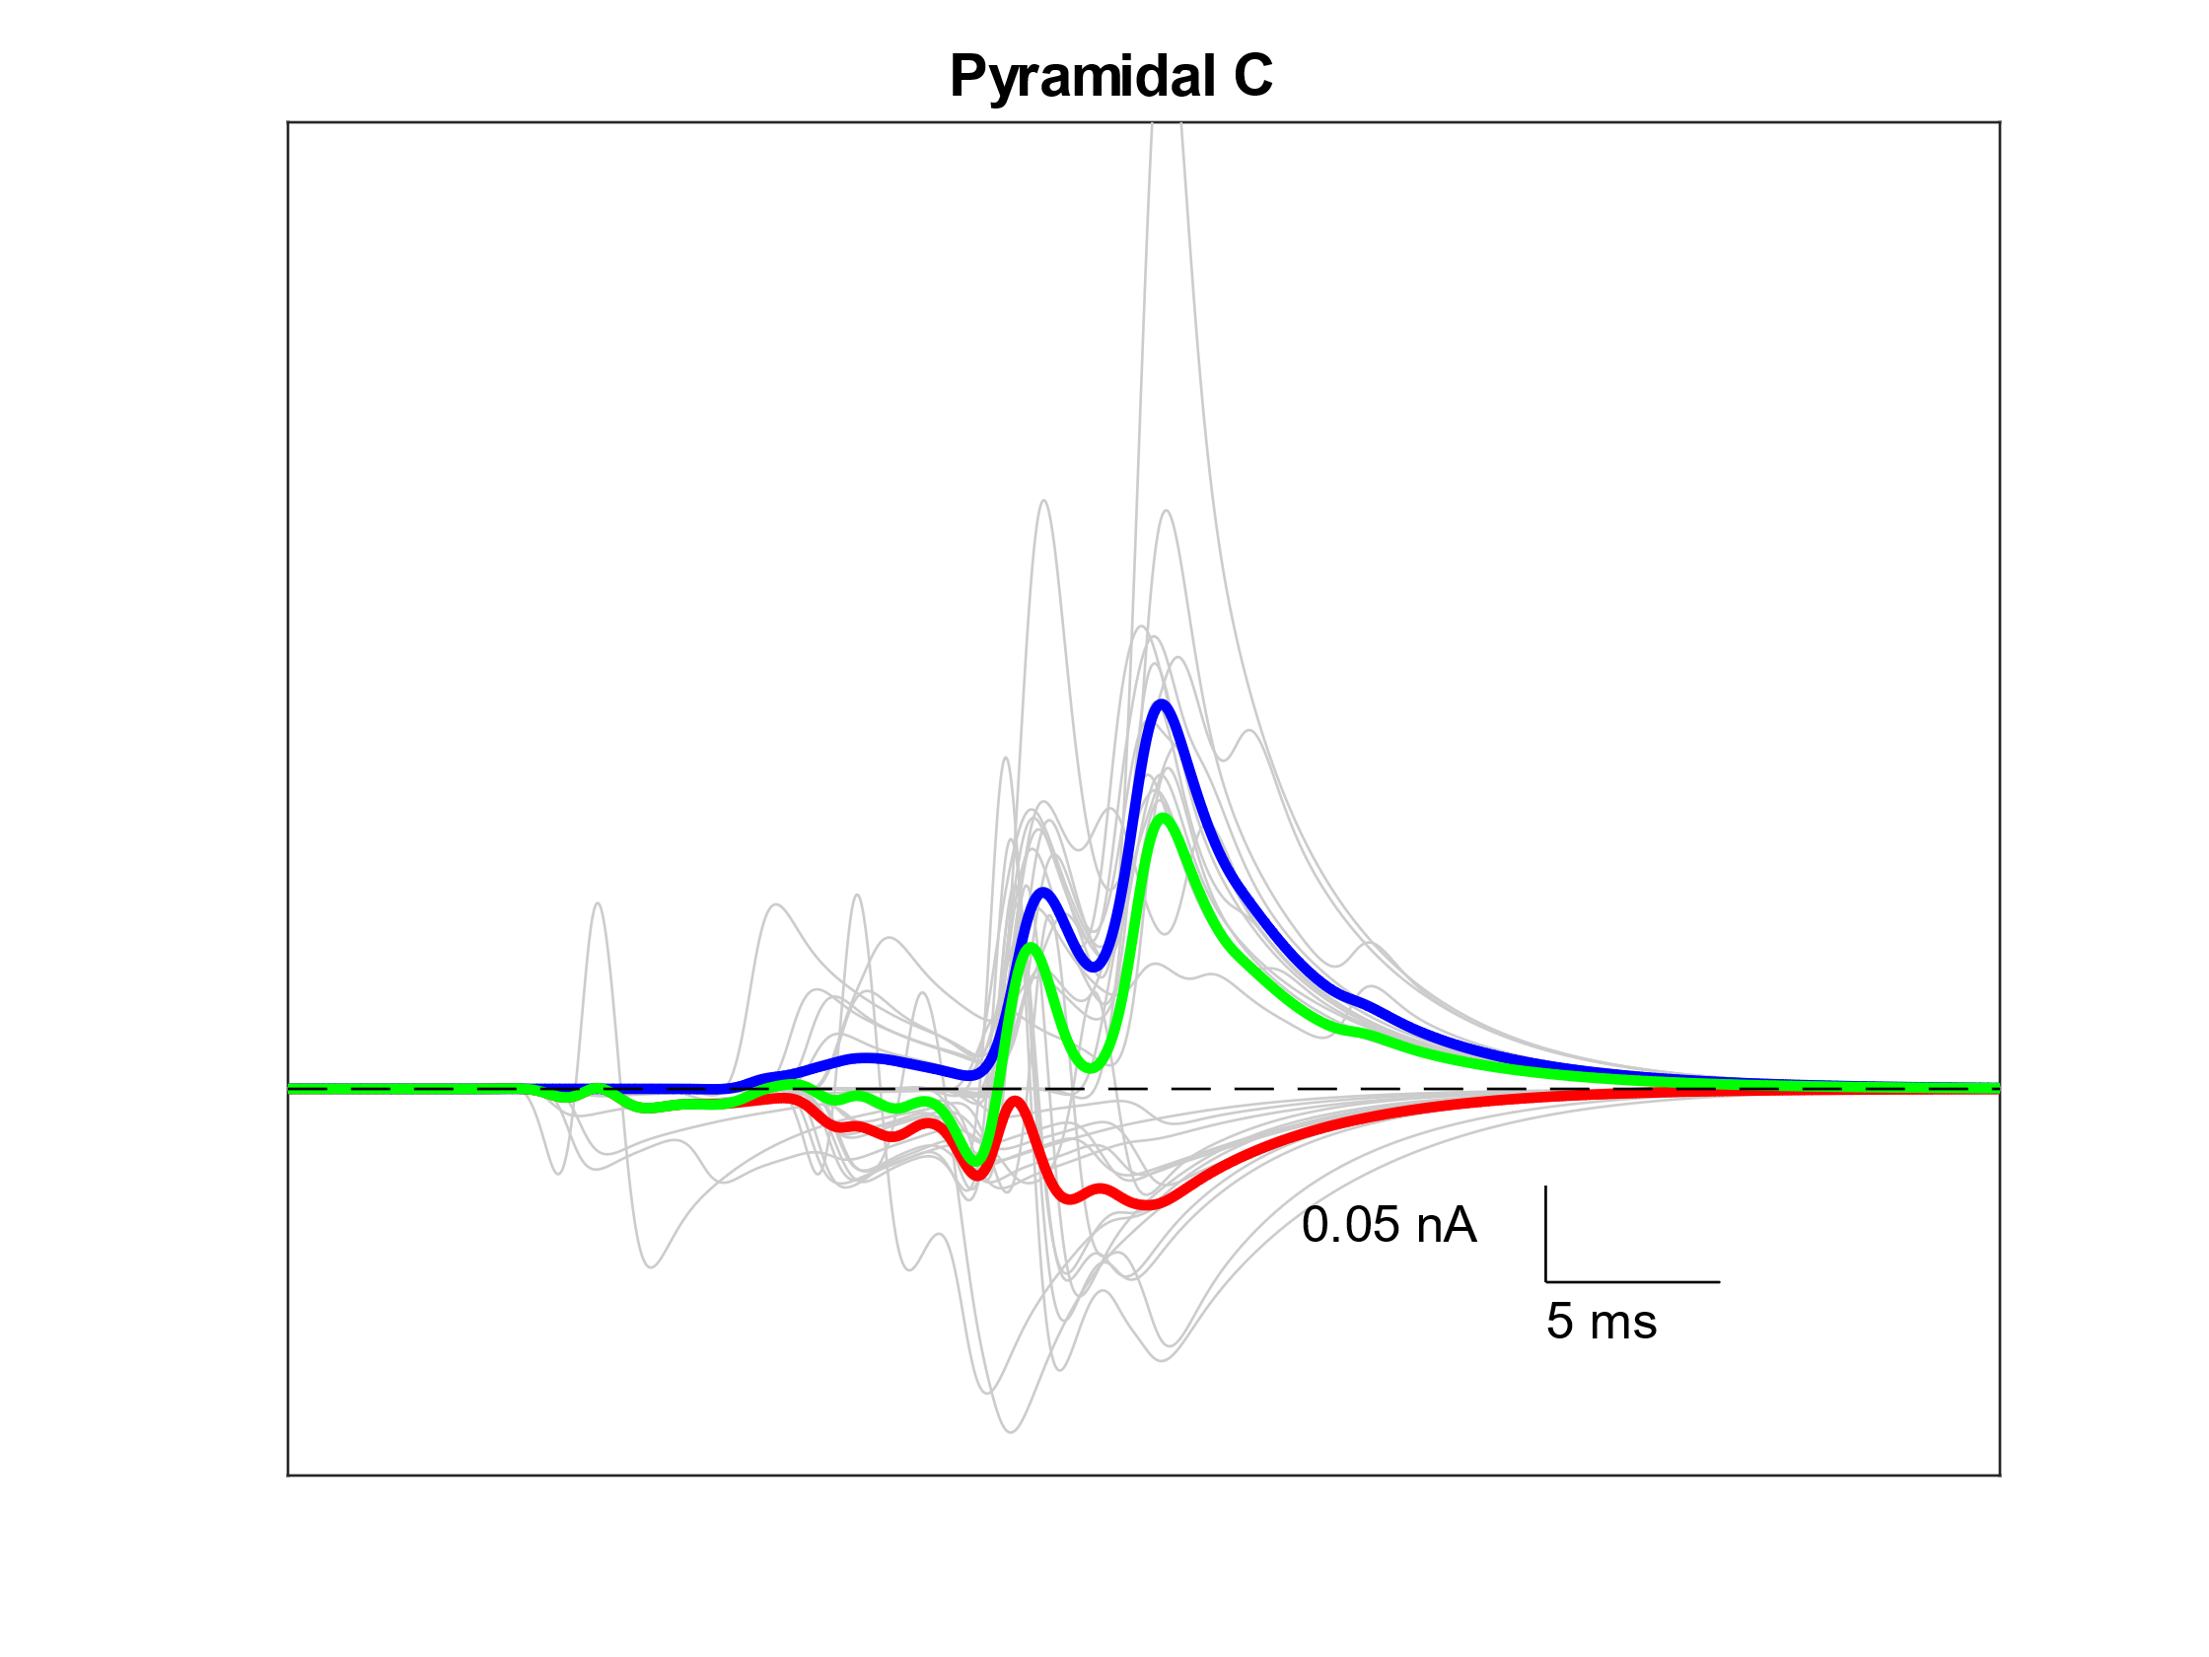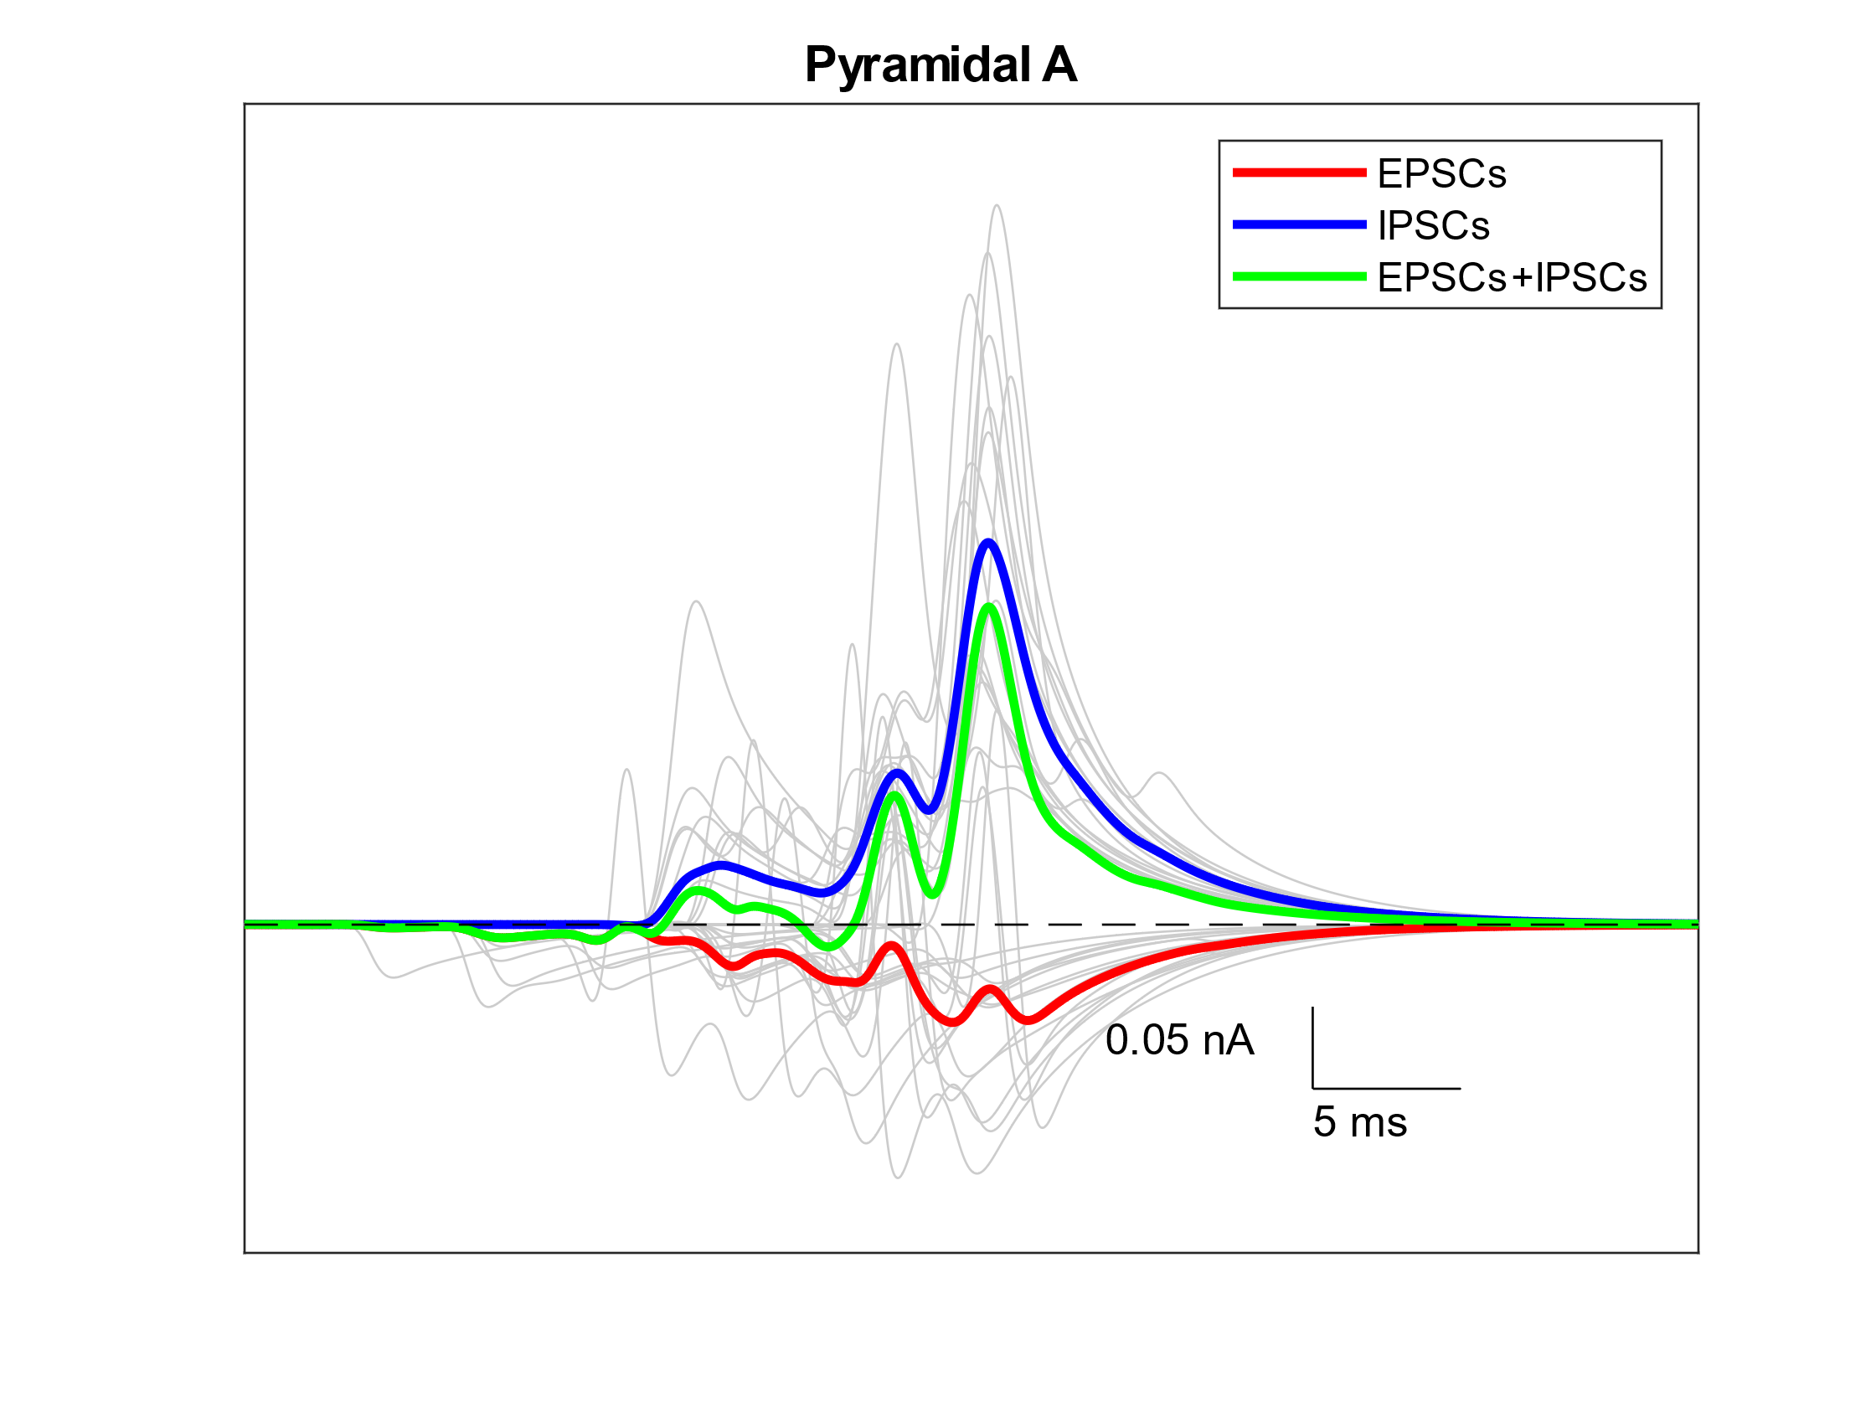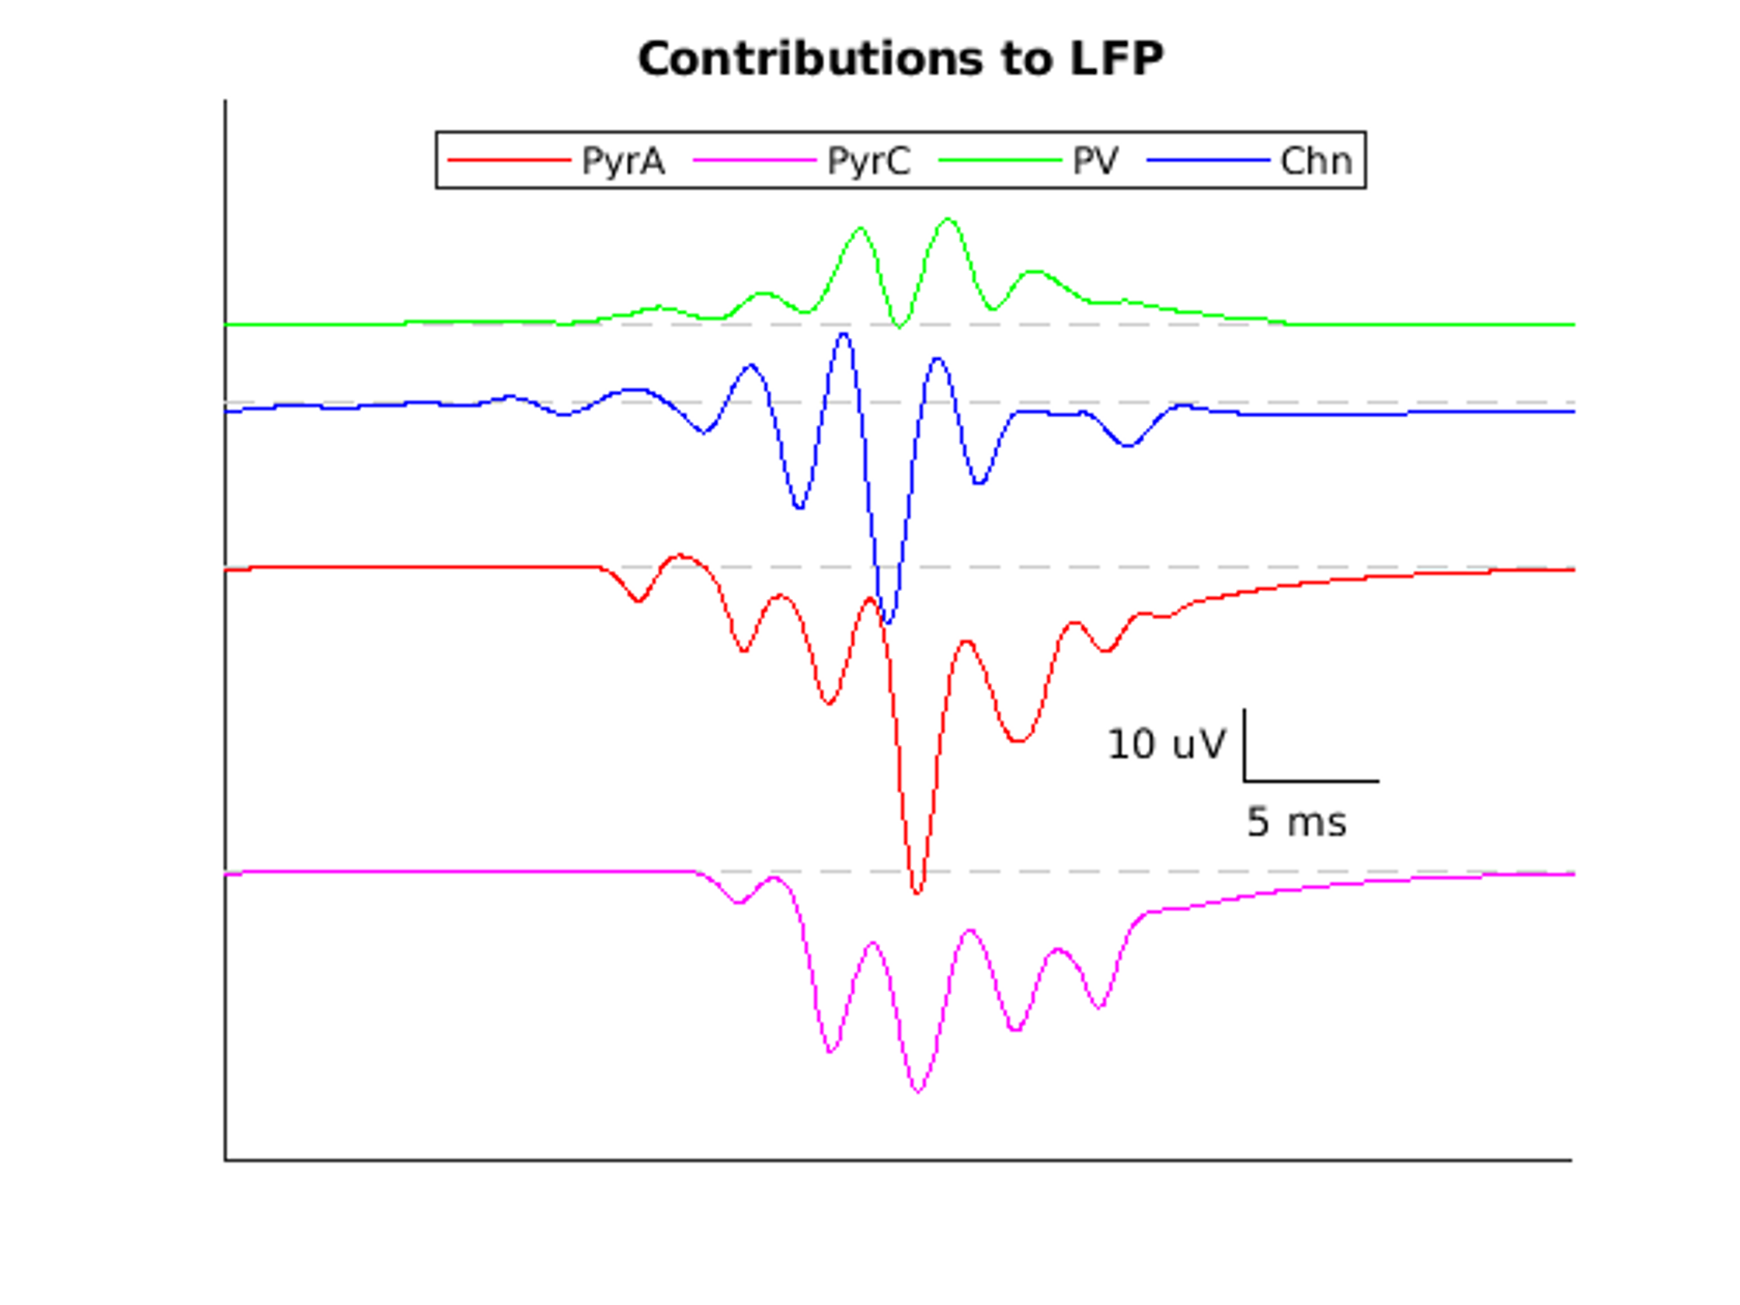**Figure 2.** Contributions of synaptic currents to the LFP. Top left is the LFP for one oscillatory event. Top right is the calculation of the LFP considering one cell type at a time. To see how synaptic events shaped the different contributions of the LFP, we recorded from 16 cells of each type that were close to the electrode. Those are shown in the bottom four plots, with the mean overlaid in color. Note the difference in y-axis scale between the pyramidal and interneuron plots.